**Table of Contents**

**1. Open Application** 1

**2. Add an Entry** 1

**3. Search for an Entry** 8

# **1. Open Application**

Once the application is launched, home page is displayed with ADD ENTRY and SEARCH buttons.

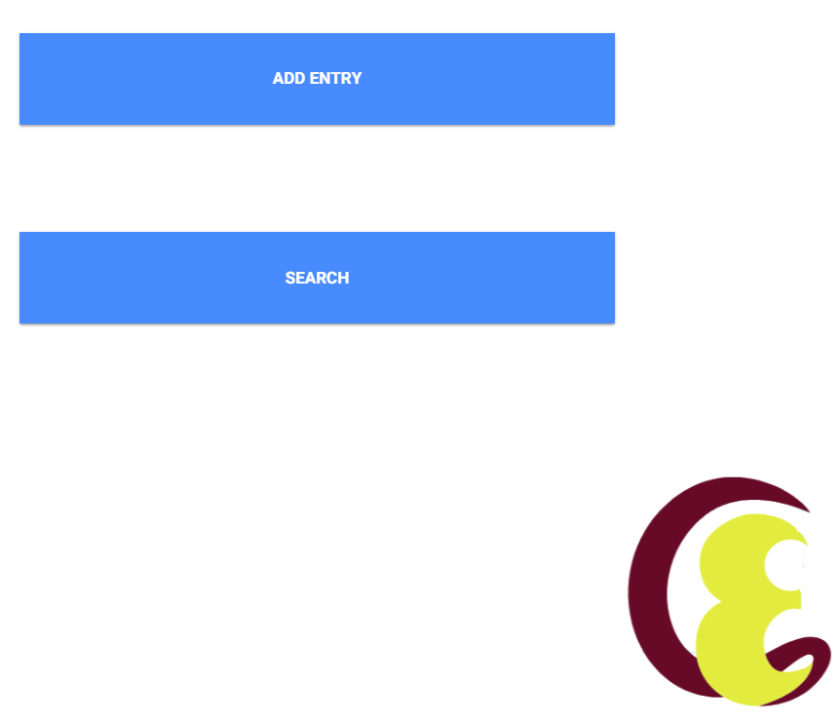

# **2. Add an Entry**

To add an entry, navigate to add entry page by clicking on Add Entry button on home page.

In the add entry page, the user can select task type from drop down if exists otherwise user can enter it below the task drop down.

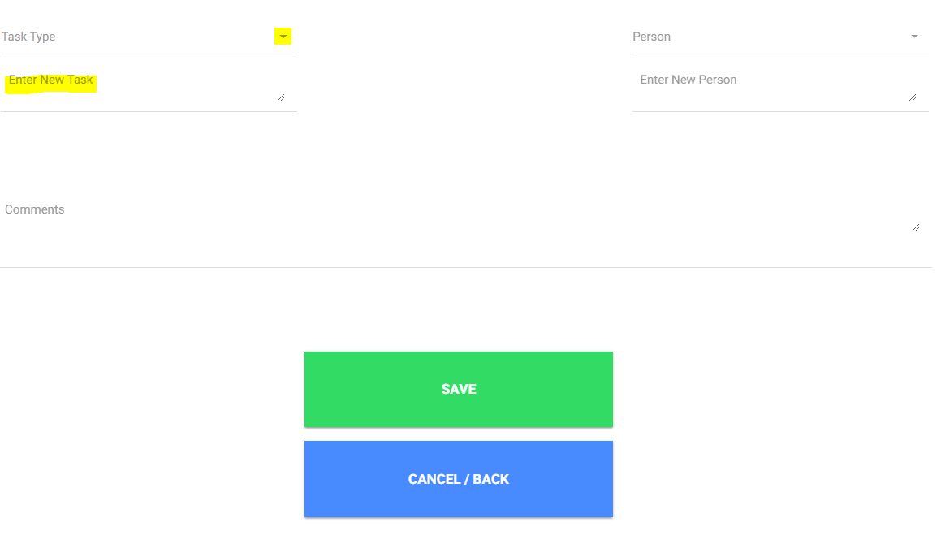

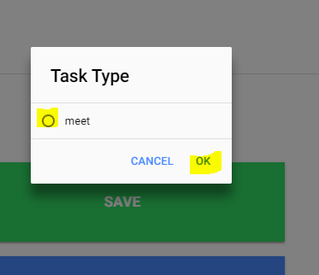

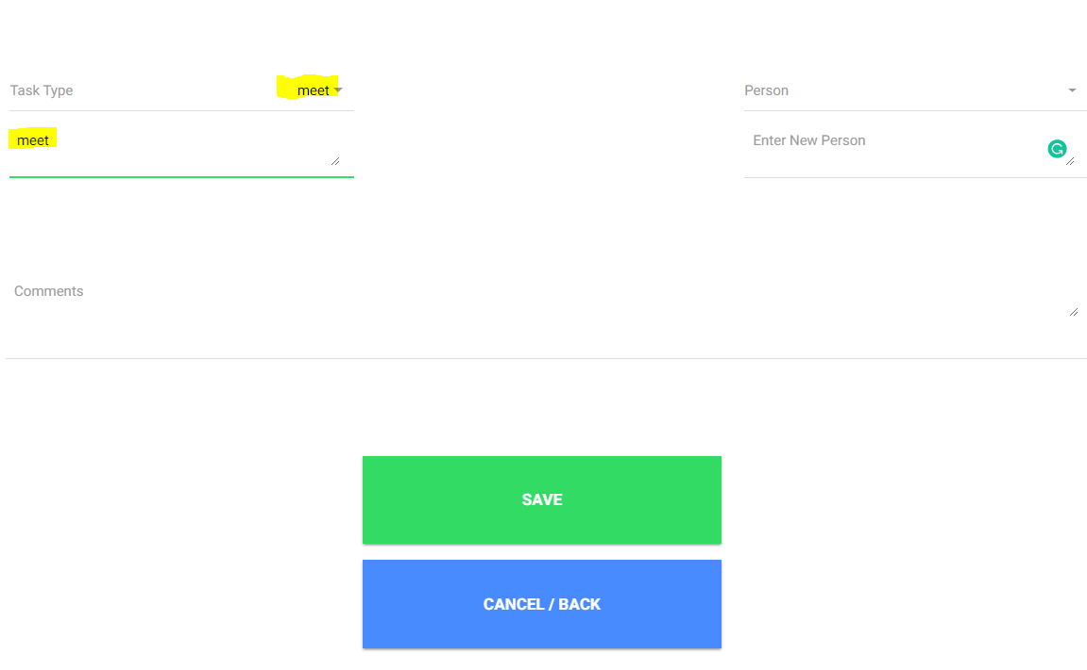

Similarly, the user can select one person or multiple persons from drop down and can enter the person name if does not exists in the drop down.

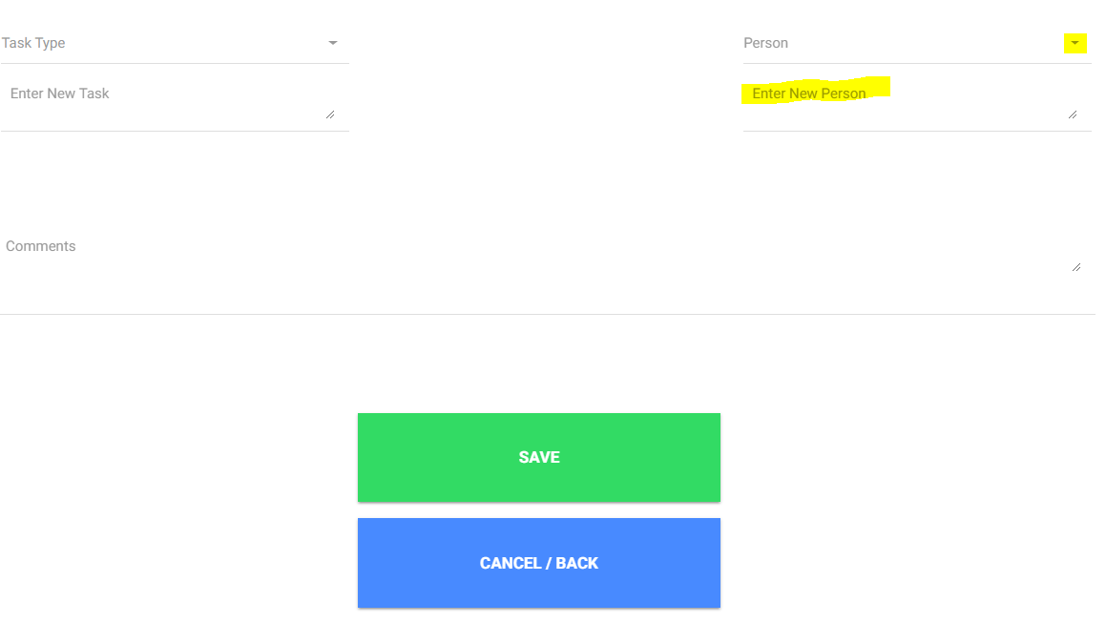

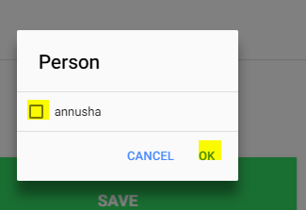

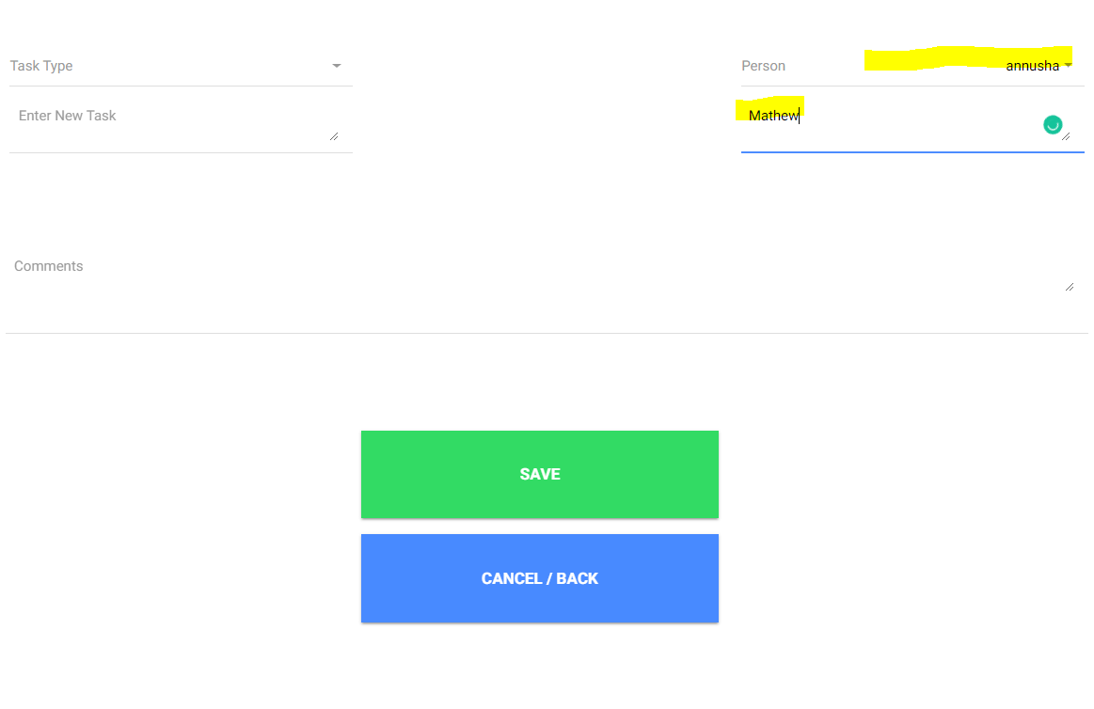

If the user has any notes related to that task, that can be entered in the comment section (writing with stylus pen or enter through keyword)

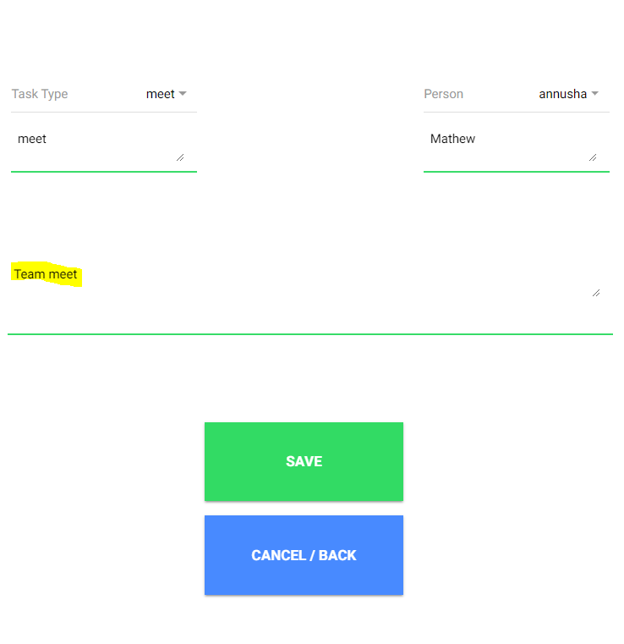

Once the task entry information is entered, the user can save the entry by clicking on the SAVE button. By Clicking on save, the entry gets stored and returns to home page.

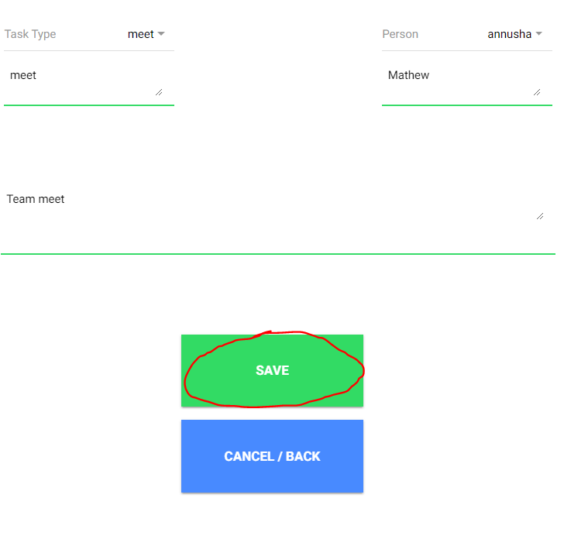

To cancel the task entry, click on CANCEL/BACK button, that navigates back to home page, here the user can again click on Add Entry Button to add another task.

In the Add Entry Page, Task type and Person fields are mandatory. If task type is not entered, it displays a pop-up window showing “Empty Task Field”

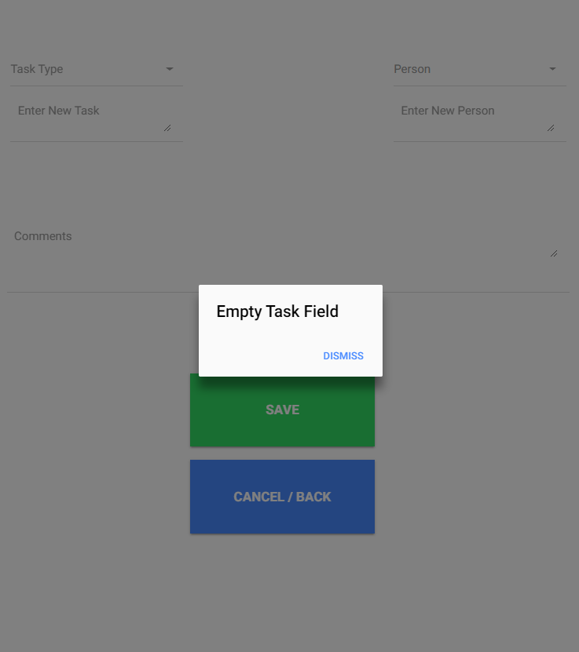

If the person field is not entered, it displays a pop-up window showing “Empty Person Field”.

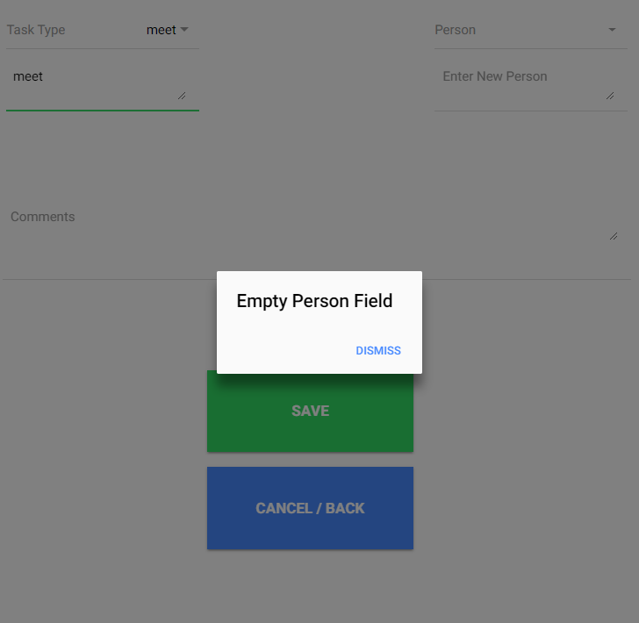

# **3. Search for an Entry**

To search for an entry, navigate to search Page by clicking on search button on home page.

In the search page, the User can search for specific entry by entering the information related to the task, say start date, end date, person name, task type or keywords in comments.

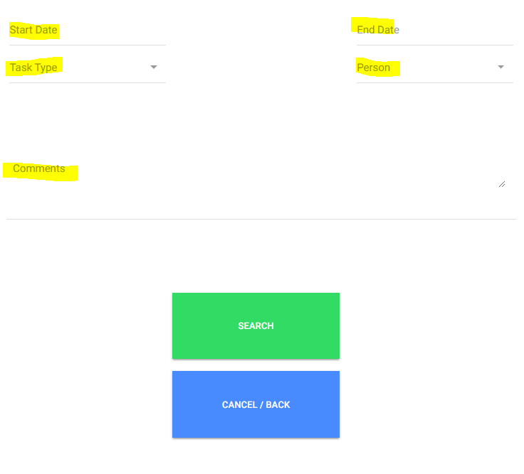

Enter start date and comments and click on search. To cancel the search, click on cancel/back button and navigate back to home page.

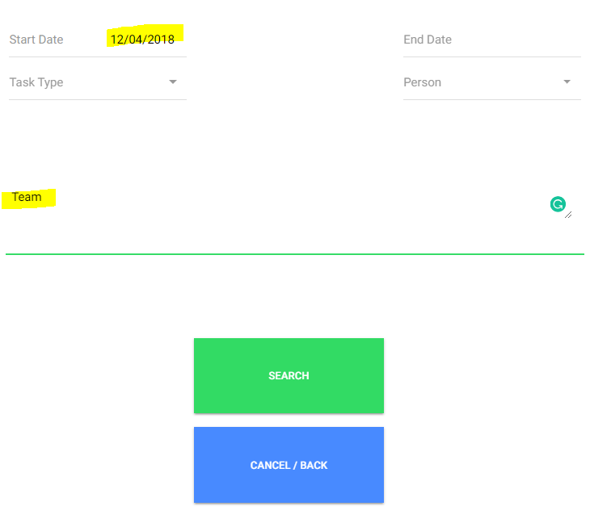

It takes to the results page, here all the results are displayed with an option to delete a task entry.

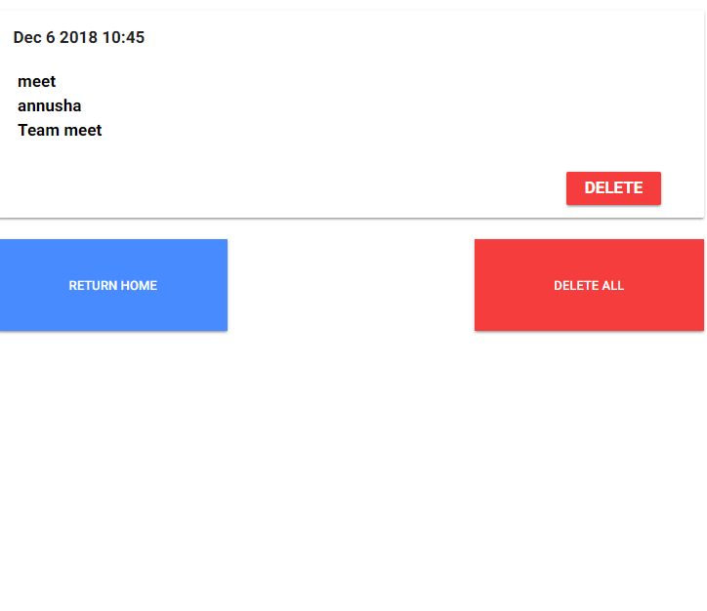

Click on delete button to delete a task entry from the device.

Click on delete all button to delete all the tasks from the device.

Click on Return Home button to navigate to home page.